Myles J Sartor
Matthew Griffin
STAT100-0121
7 November 2023
Problem Set 7
1a. 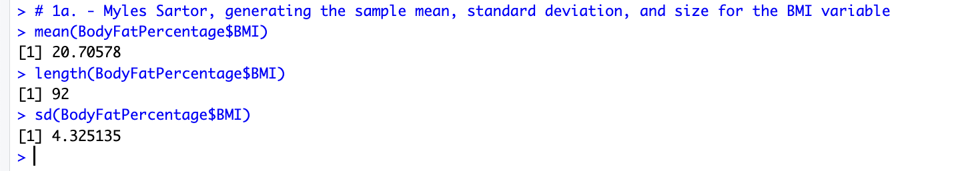
1b. 20.706 – 1.645(4.325/sqrt(92)) = 19.964 Lower bound of confidence interval
20.706 + 1.645(4.325/sqrt(92)) = 21.448 Upper bound of confidence interval
Confidence Interval: (19.964, 21.448)
1c. (19.964 + 21.448) / (2) = 20.706, sample mean = point estimate
1d. 21.448 – 20.706 = 0.742 or 20.706 – 19.964 = 0.742 = Margin of Error (can also use formula without adding/subtracting sample mean)
1e. The 90 % confidence interval for the population mean body mass index of adolescent girls is (19.964, 21.448), meaning that we are 90 % confident that the population mean BMI for these girls is between 19.964 and 21.448.
1f. 20.706 – 1.96(4.325/sqrt(92)) = 19.822 Lower bound of confidence interval
20.706 + 1.96 (4.325/sqrt(92)) = 21.590 Upper bound of confidence interval
1g. (19.822 + 21.590) / (2) = 20.706, sample mean = point estimate
1h. 21.590 – 20.706 = 0.884 or 20.706 – 19.822 = 0.884 = Margin of Error
2a. 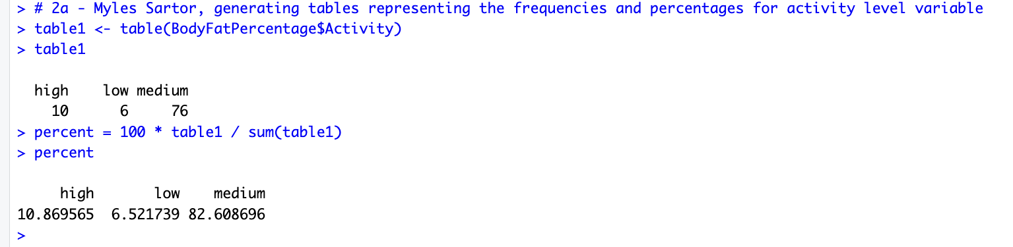
2b. 0.826 – 2.575 (sqrt(0.826(1 – 0.826) / (92))) = 0.724 Lower bound for 99 % confidence interval
0.826 + 2.575 (sqrt(0.826(1 – 0.826) / (92))) = 0.928 Upper bound for 99 % confidence interval
Confidence Interval: (0.724, 0.928)
2c. (0.724 + 0.928) / (2) = 0.826 = point estimate = population proportion
2d. 0.928 – 0.826 = 0.102 or 0.826 – 0.724 = 0.102 = Margin of Error (can also use formula)
2e. The 99 % confidence interval for the population proportion of adolescent girls with a “medium” level of activity is (0.724, 0.928), meaning that we are 99 % confident that the proportion of the population of adolescent girls with this activity level is between 0.724 and 0.928.
3a. (6.97 + 7.93) / (2) = 7.45 (can also find and use margin of error, 7.93 – 6.97, then divide it by 2 and add or subtract).
3b. 7.14 + 0.31 = 7.45 = point estimate
7.45 + 0.31 = 7.76 = upper bound or 7.14 + 0.31 (2) = 7.76
3c. n = 1 / (0.0155)^2 = 4163

